File No. 20-174

By County Executive Abele, Supervisors Nicholson, Martin, Haas, Moore Omokunde, and Johnson, Jr.

A RESOLUTION/ORDINANCE

Committing Milwaukee County, in collaboration with its departments, to advancing the strategic priority of achieving racial equity to improve the health of the entire community by eliminating any racism in the County’s policies, procedures, practices, and power structures

Whereas, according to Federal Reserve Economic data, Milwaukee is one of the most racially-segregated metropolitan statistical areas in the United States and, according to the 2019 County Health Rankings, Milwaukee County is ranked 71 out of 72 counties for health in the state of Wisconsin; and

Whereas, according to the Wisconsin Department of Health Services (DHS), in 2019 a white person in Milwaukee County lives, on average, nearly 14 years longer than a black person; and

WHEREAS, the Wisconsin DHS further reports that the infant mortality rate is nearly three (3) times higher for black infants versus white infants in Milwaukee County, at 14.2 deaths and 4.8 deaths per 1,000 births, respectively; and

WHEREAS, race is a social construction with no biologic basis, yet racism can produce an assigned societal value based on the way a person looks; and

WHEREAS, race is a consistent predictor of a person’s quality and length of life, in which black and brown communities have lower access to safe, quality: green spaces and recreation, transportation, healthcare and social services, affordable housing, education, healthy food options, clean drinking water, and financial security; and

WHEREAS, structural, institutional, and individual racism are root causes of the racial disparities in quality and length of life in Milwaukee County; and

WHEREAS, structural racism is racial bias among interlocking institutions and across society, causing cumulative and compounding effects that systematically advantage white people and disadvantage black and brown people; and

WHEREAS, institutional racism includes policies, practices, and procedures that work better for white people than for black and brown people, often unintentionally and unconsciously; and

WHEREAS, structural and institutional racism deplete the strength of the entire society through the inefficient use of human resources; and

WHEREAS, the lack of an intervention to right the wrongs of the past means that health outcomes for black and brown communities have worsened and will continue to worsen until government, including Milwaukee County, and other institutions across the county, identify and eliminate any inequitable policies, procedures, practices, and power structures; and

WHEREAS, Milwaukee County commits to supporting the Office on African American Affairs by ensuring it is strategically positioned within County government to assist with the development and institutionalization of racial equity tools to collaborate with departments to assess and transform policies, procedures, practices, and power structures to help the County become a place where all citizens are thriving; and

WHEREAS, the Office on African American Affairs has led the normalization of conversations about race and racism at all levels of Milwaukee County government to facilitate institutional change and has created a Racial Equity Ambassador program to begin transforming institutional operations, as prescribed by the model from the Government Alliance on Race and Equity (GARE); and

WHEREAS, in a unanimous decision by the County Board of Supervisors and the County Executive in May 2019 (File No. 19-397), Milwaukee County was the first governing jurisdiction in the United States to declare racism a public health crisis; however, the County must not only have a challenge statement in its legislation, but must also have a commitment to addressing the challenge, which is contained herein; and

WHEREAS, while there is no epidemiologic definition of “crisis,” the health impacts of racism clearly exemplify the definition proposed by experts, which is that the “problem must affect large numbers of people, it must threaten health over the long-term, and it must require the adoption of large-scale solutions”; and

WHEREAS, with this ordinance, the County resolves to commit to the long-term priority of achieving racial equity and by assessing and revamping policies, procedures, practices, and power structures using a racial equity lens to take down the barriers that may exist for black and brown individuals and communities so everyone in Milwaukee County can thrive; now, therefore,

BE IT RESOLVED, to transform Milwaukee County government, employees at all levels will first focus on solutions related to the following topics, which directly address power structures and institutional practices contributing to racial health disparities of County residents:
- Diverse and Inclusive Workforce: Milwaukee County leadership, management, and staff will reflect the diversity of its residents to better represent the experiences and ideas of the people it serves. The County resolves to build a collaborative, supportive, respectful workplace environment that increases the participation and contribution of all employees.
- Employee Perspective: To enhance the health of Milwaukee County residents, County government should strive to ensure that services meet everyone’s needs. Thousands of Milwaukee County employees directly serve residents each day and their perspectives should be more intentionally considered to continually improve the equity of policies, procedures, practices, and power structures.
- Customer-Focused Design: A “customer” is defined as an individual who currently uses or could use County services; customers may include Milwaukee County residents, visitors to Milwaukee County, or Milwaukee County employees. Government services should meet the needs of its customers. Redesigning what, where, and how services are provided to meet customer needs should be undertaken with customer participation. Defining customer populations and including those customer groups in the design and decision-making of services will help ensure that government services are meeting the needs of those using, or who could be using, County services. To this end, the County must focus on purposeful and meaningful community engagement on the front-end and throughout the process of decision making, which will produce more appropriate and equitable power-sharing between experts working in the government and the customers of County services.
- Improved Performance & Equitable Practice: Milwaukee County government must improve the quality of the data it collects and the analysis of that data to better understand the impact of services on customers. It is not enough to assume that a service is producing its intended outcome; the County should use qualitative and quantitative data to assess impact and continuously improve where services are falling short in order to improve the quality of life for all residents.
- Fiscal Health: Over the past decade, Milwaukee County has cut between $20 and $30 million annually due to the structural deficit and has accumulated hundreds of millions of dollars in deferred maintenance. Because of decisions made decades ago and the restrictive authority given to local governments to generate new sources of revenue, the County and municipal governments are forced to make decisions about cuts to services and repairs each year that can impact the health of County residents. The County must find sustainable revenue sources and continue to pursue organizational efficiencies so the County government can make meaningful investments to advance racial equity

; and

BE IT FURTHER RESOLVED, that every employee is responsible for the implementation of this Resolution/Ordinance and developing skills and capacities to create and maintain a culture in which employees recognize and respect the diverse values, beliefs, and behaviors in the workforce and the community they serve; and

BE IT FURTHER RESOLVED, that to address systemic racism affecting county residents, Milwaukee County government commits to engaging municipalities and institutions within the county to prioritize racial equity to address structural racism producing disparate population health outcomes; and

BE IT FURTHER RESOLVED, that by achieving racial equity, Milwaukee County will eliminate health and opportunity gaps along racial lines and will increase the success of all groups by distributing resources justly across all communities; and

BE IT RESOLVED, that the Milwaukee County Board of Supervisors hereby creates Chapter “Achieving Racial Equity and Health” of the Milwaukee County Code of General Ordinances by adoption of the following:

AN ORDINANCE

The Milwaukee County Board of Supervisors does ordain as follows:

Section 1. Chapter 108 “Achieving Racial Equity and Health” of the Milwaukee County Code of General Ordinances is hereby created as follows:

108.01 – Achieving Racial Equity and Health.

Racism has been and is a public health crisis in Milwaukee County. According to the County Health Rankings, Milwaukee County is, and has consistently been, one of the lowest-ranked counties for health in Wisconsin and, according to Federal Reserve Economic Data, Milwaukee County is one of our nation's most racially segregated areas. According to 2019 statistics, a white person lives, on average, nearly 14 years longer than a black person and the infant mortality rate is nearly three (3) times higher for black infants compared to white infants. Race is a social construction with no biologic basis, yet racism may produce an assigned societal value based on the way a person looks that has resulted in race being a consistent predictor of a person’s quality and length of life. With this ordinance, Milwaukee County government declares its commitment to achieving racial equity by identifying and eliminating any racism in its institutional policies, procedures, practices, and power structures for black and brown individuals and communities so everyone in Milwaukee County can thrive.

108.02 – County Strategic Priority, Mission, Vision, and Values

- The institutionalization of racial equity in the County’s mission, vision, values, and services are of the utmost priority. Milwaukee County government declares that:
  - Racism has been, is, and will continue to be, a public health crisis until race is no longer a predictor of quality or length of life in Milwaukee County.
  - The vision of the County be: “By achieving racial equity, Milwaukee is the healthiest county in Wisconsin.”
  - The mission of the County be: “We enhance the quality of life in Milwaukee County through great public service.”
  - The values guiding the culture of the County workforce be:
    - Respect: We work with and for others.
    - Integrity: We do the right thing.
    - Excellence: We never stop improving.

108.03 – Guiding Framework and Strategic Objectives to Achieve the County’s Vision
- Milwaukee County adopts the “Health and Equity Framework,” adapted from the Wisconsin Population Health Institute’s model, as its guiding framework for addressing the root causes of institutional and systemic racism. The framework first directs that influencing the “Power to Make Change” is the most sustainable and transformational way to affect racial equity and health in the County population. The second key area that the framework directs focus to is “Institutional Practices,” which entails identifying and eliminating any racial biases in governmental practices. By addressing these two causal areas of racial and health inequities, Milwaukee County will make huge strides in advancing its vision of achieving racial equity and being the healthiest county in Wisconsin.
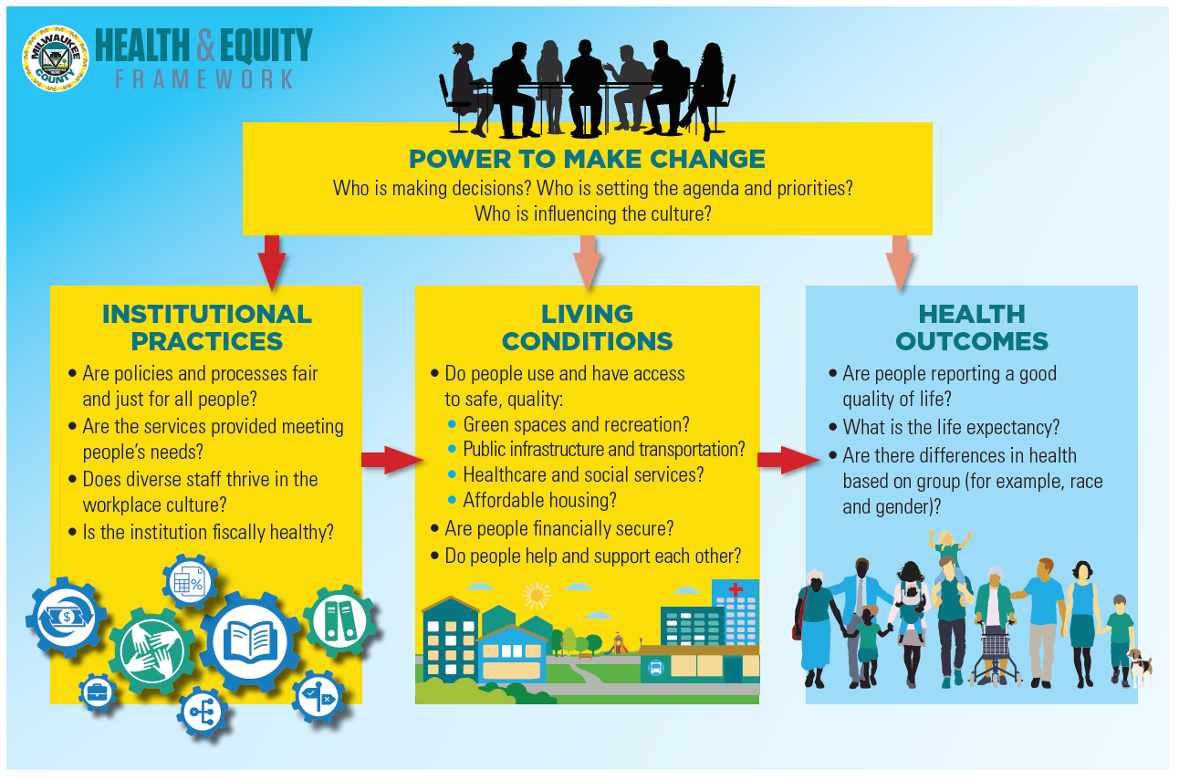

- To this end, Milwaukee County government declares that it will achieve the following objectives, which directly affect the “Power to Make Change” and “Institutional Practices”:
  - Diverse and Inclusive Workforce:
    - Milwaukee County leadership, management, and staff will reflect the demographics (including, but not exclusively racial) of Milwaukee County.
    - Milwaukee County will have an inclusive workplace culture where differences are welcomed, where different perspectives are heard, and where individuals feel a sense of safety and belonging.
    - Employees will understand what skills and experience are expected to advance to the next level and will have opportunities to gain those skills and experiences.
  - Employee Perspective:
    - Milwaukee County leaders and management will regularly consult and problem solve with a racially diverse representation of frontline staff to inform equitable policy, process, and customer service delivery decisions.
  - Customer-Focused Design:
    - Milwaukee County will determine what services we offer and how money is spent based on robust, diverse public participation.
    - Milwaukee County will determine where services are offered based on robust, diverse public participation.
    - Milwaukee County will determine how services are offered based on robust, diverse public participation.
  - Improved Performance and Equitable Practice:
    - Milwaukee County will monitor and evaluate the impact and equity of all services on customers and will use data to continuously improve.
    - Milwaukee County will be held accountable by external partners and community members for progress and results on the strategic plan.
  - Fiscal Health
    - Milwaukee County will secure additional revenue and achieve cost savings each year to be able to cover existing operating costs.
    - Milwaukee County will identify and implement mechanisms to make investments into strategic priorities to achieve the objectives outlined above.
- Milwaukee County declares that it will, at a minimum, use racial equity tools to evaluate the impact of decisions on black and brown communities for the following enterprise-wide areas:
  - The budget
  - Processes, policies, and procedures
- Milwaukee County declares that it will continue to offer trainings to support racial equity work at all employee levels.
- Milwaukee County declares that every informational and action report that is submitted to the County Board will incorporate the impact on the vision and connection to racial equity and the strategic objectives.
- Milwaukee County declares that it will create and maintain an external website dedicated to racial equity and health work at the County.
- Milwaukee County declares that it will create and maintain an intranet site dedicated to racial equity and health work at the County.

108.04 – Key Stakeholder Roles and Responsibilities

- The County directs that the stakeholders below will carry out the described roles and responsibilities in support of the successful execution of the strategic objectives outlined in this ordinance:
  - County Leaders, Managers, and Staff: Leaders are accountable for the success of the objectives outlined above to advance racial equity in Milwaukee County. Furthermore, every employee is responsible for the implementation of this Resolution/Ordinance and developing skills and capacities to create and maintain a culture in which employees recognize and respect the diverse values, beliefs, and behaviors in the workforce and the community they serve.
  - Office on African American Affairs: The Office provides guidance, education, research, and technical assistance to support the County vision and strategic planning priorities.
  - Strategic Plan Advisory Council: Milwaukee County declares that it will create a Strategic Plan Advisory Council. The Advisory Council shall provide both input on and support for the implementation of solutions designed to advance Milwaukee County’s vision of achieving racial equity and becoming the healthiest county in Wisconsin. The Advisory Council shall consist of eleven (11) representatives:
    - One (1) chairperson, who must be a Milwaukee County employee and shall be nominated by the County Executive and approved by the County Board Chairperson.
    - Three (3) County Board Supervisors selected by the County Board Chairperson.
    - One (1) Elected Official from the District Attorney’s Office, the Chief Judge’s Office, the Clerk of Courts, or the Milwaukee County Sheriff’s Office, who will be nominated by the County Executive and approved by the Chairperson of the County Board of Supervisors; in the event that none of these elected officials serve on the Advisory Council, their seat will be filled by an additional external partner, following the same rules as outlined in 108.04 (1)(c)(viii).
    - One (1) Elected Official from the Register of Deeds Office, the Office of the Comptroller, the Office of the County Clerk, or the Office of the Treasurer, who will be nominated by the County Executive and approved by the Chairperson of the County Board of Supervisors; in the event that none of these elected officials serve on the Advisory Council, their seat will be filled by an additional external partner, following the same rules as outlined in 108.04 (1)(c)(viii).
    - The Director of the Office on African American Affairs.
    - Two (2) Department Directors selected by the County Executive.
    - One (1) non-supervisory Racial Equity Ambassador selected by the Office on African American Affairs and approved by the Ambassador’s Department Director.
    - One (1) community member, who will be nominated by the County Executive and approved by the Chairperson of the County Board of Supervisors.
The composition of the Advisory Council shall be assembled with diversity at the front of mind.
The Advisory Council shall convene at least once each quarter, or four times annually. In addition to monitoring the County’s progress toward realizing the objectives outlined in the County’s strategic plan, the Advisory Council shall provide input and support for overcoming obstacles encountered by County employees working to advance the plan.

As appropriate, the Advisory Council shall provide input on the refinement and implementation of the strategic plan. Recommendations for significant changes to the plan (for example, changes to wording of the objectives, or reallocating employee time or County resources to achieve the objectives) shall require a written recommendation to both the County Executive and the County Board Chair for consideration and approval.

The Director of Strategic Planning and the County Board Chairperson’s Chief of Staff or their designees shall jointly prepare the agenda and materials for the meetings. One or both of individuals shall (co-)facilitate each meeting.
Section 2. The provisions of this Ordinance shall become effective upon passage and publication.

